Welcome to the Integrated Clarkson Experience (ICE) Program!

ICE is a college prep program designed for students who are in their sophomore, junior, and senior years of high school who are currently or were previously involved with the NYSED STEP Program at Clarkson (known as IMPETUS for Career Success). Now that you are in high school, your goals and interests are probably changing as you look forward to after high school. This program will help you think and plan your future based on your interests and goals! As a participant in ICE, you are matched with a Clarkson Student Mentor who has similar interests. The best advice can come from students who have been in your shoes!

With your Mentor, you will participate in self-assessment activities, have one on one meetings, explore STEM fields, learn more about your goals and interests and conquer the college application process. They will help you deal with challenges you may face as you plan for your future.

The program will start in the fall and conclude throughout the school year. In addition to scheduled meetings through Zoom or email, each month you will also have the opportunity to meet with your mentor during the monthly school visit to Clarkson. The good news is that the program is flexible to match your busy schedule. As part of the program, you and your mentor will complete a Road Map to Success booklet to help with important choices that will come up over the next years. In addition, you can participate together in a variety of personal and professional development activities and college visitation days as scheduled.

We hope you accept this invitation to pair with you a Clarkson University student! To join the ICE, please complete the attached Mentor Program application that will be used to pair you with a Clarkson student. Please return your Mentor Program Application to your coach or to me via email.

We look forward to working with you!

Sincerely,
Brenda R. Kozsan
Mentoring Director
bkozsan@clarkson.edu : 315-268-4330

MENTOR PROGRAM APPLICATION

ICE (Integrated Clarkson Experience)
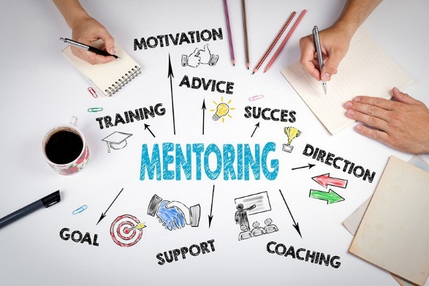
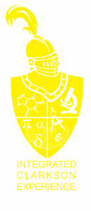

Why should you participate in the Integrated Clarkson Experience (ICE) program? What is ICE?
- ICE is a college prep program designed specifically for students in their sophomore, junior and senior years of high school who are currently or were previously involved with the NYSED STEP Program at Clarkson (IMPETUS for Career Success).
- Since you are in high school, your goals and interests are probably changing as you look forward to life after high school. Through this program, you are provided with support and guidance as you make those decisions.
- Based on your profile, you are matched with a Clarkson Student Mentor. There will be regular scheduled activities and meetings with your mentor who will help you explore options for after high school and life!
How will this program and a mentor help me?
- Mentors will help you prepare for and deal with challenges as you navigate your present and future through regular meetings (in person, Zoom or through emails).
- The Road Map to Success booklet will help you discover your values and skills, determine your short and long-term goals and prepare a plan for the future.
- You will learn and grow through a variety of other activities scheduled throughout the year including college visitation days and programs.

We hope you will accept this invitation to join ICE and be matched with one of our mentors. We are excited to get to know you and assist you on your journey!

Please complete the attached profile about you as well as your interests and hobbies, which will be helpful in pairing you with a mentor. Please return this profile to your coach or send to me via email at bkozsan@clarkson.edu. If you have any questions, please email bkozsan@clarkson.edu anytime!

Brenda R. Kozsan, IMPETUS ICE Mentoring Director

ICE STUDENT PROFILE AND INFORMATION
Personal Information:
Name _____________________________________________________________________________
Date of Birth ______________________________ Gender: M F Other
Preferred T-shirt size: Small Medium Large XL XXL XXXL
Name of School: ________________________________________ Grade: __________________
Your Home Address: _________________________________________________________________
Street City State Zip
Home Phone: ____________________________ Email: ________________________________
Parent/Guardian(s) Name: ____________________________________________________________
Phone number of Parent/Guardian: ____________________________________________________
Emergency Contact Name: ____________________________________________________________
Relationship of Emergency Contact: ____________________________________________________
Emergency Contact’s Phone Number: ____________________________________________
Interests and Hobbies (please feel free to share what you feel comfortable):
Favorite Food: __________________________ Favorite Movie: _______________________
Favorite Book: __________________________ Favorite Class: _________________________
Favorite Music/Song: ____________________ Favorite Activity: ______________________
What are you hoping to do as a career in the future? (It is okay if you are undecided!) _____________________________________________________________________________
If you participate in extracurricular activities in or outside of school, please list them here:
______________________________________________________________________________

Class Information:
What subjects are difficult for you, if any? __________________________________________
What classes are easiest for you, if any? ____________________________________________
What classes do you like the most? ________________________________________________
What classes do you like the least? ________________________________________________

Mentor Matching Information:
In the list below, please circle what you would like assistance for from your mentor:
Selecting a career
Selecting a major
Emotional Support
General Advice/someone to talk to
Deciding on goals
Help me grow my skills
Assistance with school/homework
Other (Be Specific) ______________________________________________________

Of the below, what would you be willing to share with your mentor? Circle all that apply.
My email
My phone number to text
My phone number to call
Facebook/Instagram/Social Media

Class Information:
What subjects are difficult for you, if any? _____________________________________________
What classes are easiest for you, if any? _______________________________________________
What classes do you like the most? __________________________________________________
What classes do you like the least? __________________________________________________

Other Information:
What else would you like us to know about you when matching you with a mentor? ____________________________________________________________________________________________________________________________________________________________________________________________________________________________________________________________________________________________________________________________________________________________________

